# [**'Law & Order: SVU' Season 22 Could See More Returning Faces Than Stabler**](https://www.tvinsider.com/951208/law-order-svu-season-22-returning-cast-stabler-coronavirus/)

[***Ileane Rudolph***](https://www.tvinsider.com/author/ileane-rudolph/)4 HOURS AGO

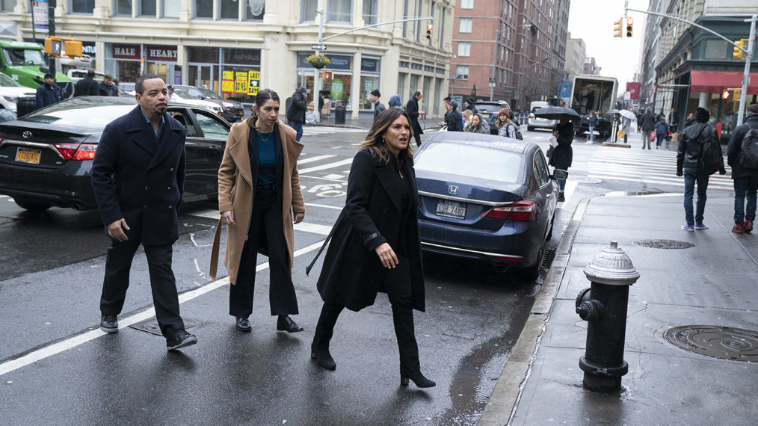

##### FALL PREVIEW

Heidi Gutman/NBC/NBCU Photo Bank via Getty Images

What a difference six months make: New York is "a city struggling to return from a harrowing pandemic and months of demonstrations and political fallout after George Floyd…a city that has lost faith in the NYPD and the DA's office," [***Law & Order: SVU***](http://tvinsider.com/show/law-order-svu) executive producer [**Warren Leight**](http://tvinsider.com/people/warren-leight) says.

The drama's 22nd season opens with an assault in Central Park that "quickly turns into a racially volatile situation, and [the unit] confronts how their own racial bias affects their judgment." After a case about domestic violence, Episode 3 turns to what happens after extended social isolation and quarantine due to COVID-19 — or, says Leight, "how close people get to their breaking points."

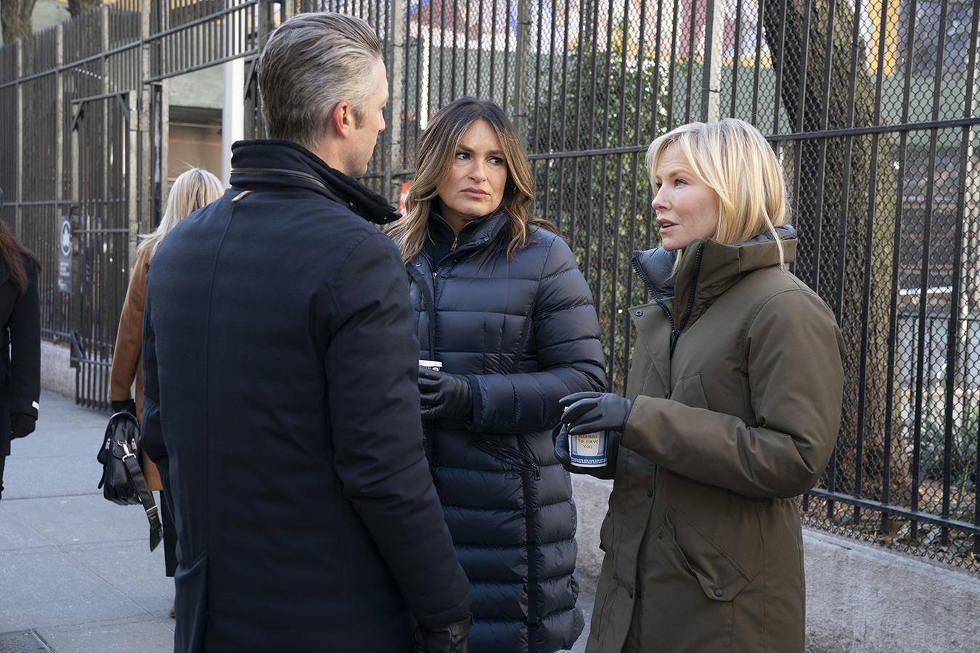

(Virginia Sherwood/NBC/NBCU Photo Bank via Getty Images)

On the bright side, after 10 years apart, onetime SVU detective Elliot Stabler ([**Christopher Meloni**](http://tvinsider.com/people/christopher-meloni)) visits his former partner, now-captain Olivia Benson [**(Mariska Hargitay)**](http://tvinsider.com/people/mariska-hargitay), as a lead-up to Meloni's 2021 spinoff, *Law & Order: Organized Crime*.

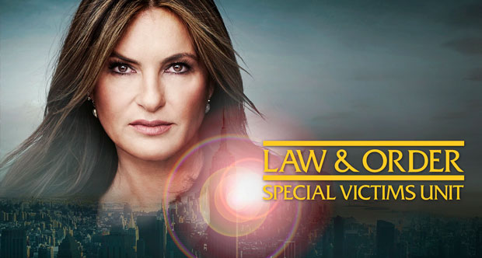

#### **DON'T MISS A THING!**

###### Get **absolutely everything** about **Law & Order: SVU** in your inbox!

Happily for fans, there's even more nostalgia in the offing. Says Leight: "We hope to bring back some [more] past regulars this season."

***Law & Order: SVU*, Season 22 Premiere, Thursday, November 12, 9/8c, NBC**